**ABS (chimei)**

ABS is a copolymerization of styrene, acrylonitrile, and butadiene latex. Its heat and solvent resistance properties are better than HIPS and it has gloss characteristics. Because acrylonitrile has stronger nitrile polarity, it can enhance the interaction of the PS in the molecular chain. Therefore, its impact strength, tensile strength, and plastic surface hardness are better compared to those of HIPS.

Generally, the higher the content proportion of acrylonitrile, the better the heat resistance, rigidity, and solvent resistance properties; but the fluidity is worse and the plastic contains a yellow color. During injection mode, it has very good mechanical property and dimensional stability. Based on these advantages, the ABS resin has become an excellent engineering plastic.  
The POLYLAC® ABS Resin of Chimei is currently the most diverse acrylonitrile-butadiene-styrene copolymer. Our unique technology allows the ABS resin to provide special combinations of strength, stability, and workability. The quality, dyeability, and appearance of Chimei’s POLYLAC® is deeply trusted and preferred by the customers.  
POLYLAC® has been widely accepted and applied to commercial machinery, electronic components, communication facilities, personal computers, and electrical appliances, auto parts, shower appliances, luggage, faucets, and other household goods. Certified by the UL and C-UL, POLYLAC® covers a variety of specifications in the market such as the general grade, high flow grade, extrusion grade, fire proof grade, and heat resistant grade.

[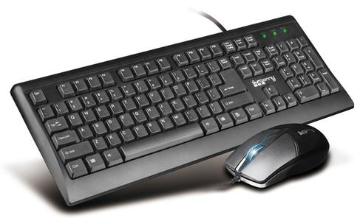](http://image.baidu.com/i?ct=503316480&z=&tn=baiduimagedetail&ipn=d&word=%E9%94%AE%E7%9B%98%E9%BC%A0%E6%A0%87&step_word=&ie=utf-8&in=23371&cl=2&lm=-1&st=-1&pn=7&rn=1&di=78870237930&ln=1686&fr=&&fmq=1392360756176_R&ic=0&s=&se=1&sme=0&tab=&width=&height=&face=0&is=&istype=2&ist=&jit=&objurl=http%3A%2F%2Fwww.wdeee.cn%2Fuploadfile%2F2012%2F0606%2F20120606111620650.jpg)[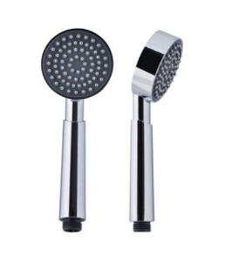](http://image.baidu.com/i?ct=503316480&z=&tn=baiduimagedetail&ipn=d&word=ABS%E5%AE%B6%E5%B1%85&step_word=&ie=utf-8&in=21522&cl=2&lm=-1&st=&pn=14&rn=1&di=23153836420&ln=1999&fr=&&fmq=1392361127073_R&ic=&s=&se=&sme=0&tab=&width=&height=&face=&is=&istype=&ist=&jit=&objurl=http%3A%2F%2Fstatic.house.sina.com.cn%2Fshopjiaju%2Fgoods_csv%2F11%2F111%2Fm-d3d4ee15b483fe9b0dd72175ab3389d7.jpg)